|  |
| --- |
|  |
|  |

|  |  |  |  |  |  |
| --- | --- | --- | --- | --- | --- |
| REVISION HISTORY | | | | | |
| Ver. | Description of Change | Author | Date | Approved | |
| Name | Effective Date |
| 1.0 | Initial status | [Arina](mailto:Kiryl_Bucha@epam.com) Marchenko | 19-11-2017 |  |  |

Contents

1. Hands-On Task 3

2. Data Modeling Task 3

3. Analytical task 3

3.1. Partitioning 3

3.2. Business 3

4. Results 3

# Hands-On Task

1. Adding table with partitions:

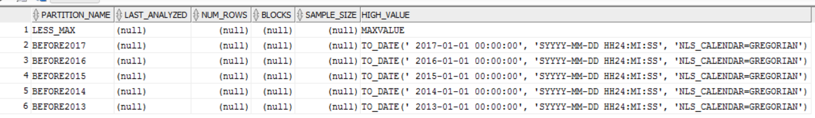

1. Drop Partitions BEFORE2013 & BEFORE2014

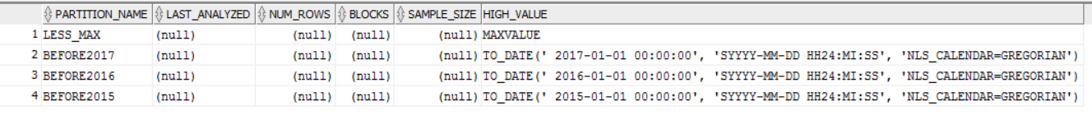

1. If we try to alter the partition, we can do it only if values are after the existing

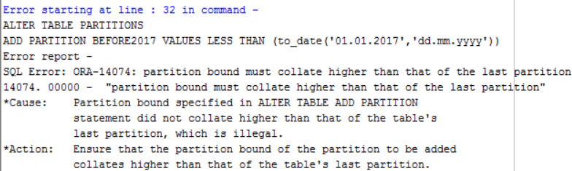

So I dropped LESS_MAX & BEFORE2017 and then altered partition BEFORE2017

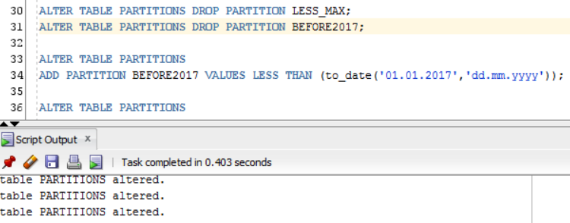

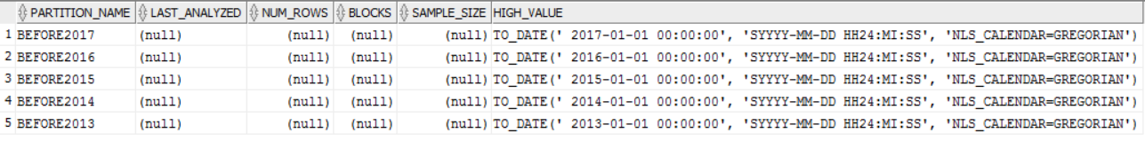

1. Merge partitions BEFORE2016 & BEFORE2017

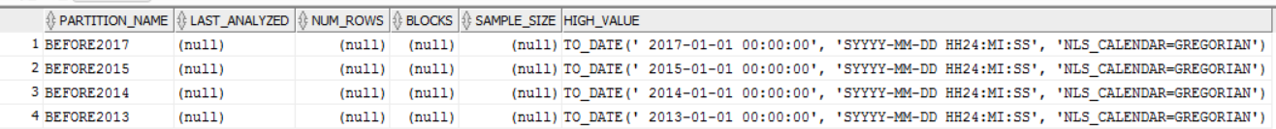

1. Moving partition. We move partition BEFORE2017 to another tablespace users. We can do it for:

* Re-cluster data and reduce fragmentation
* Move a partition to another tablespace
* Modify create-time attributes
* Store the data in compressed format using table compression

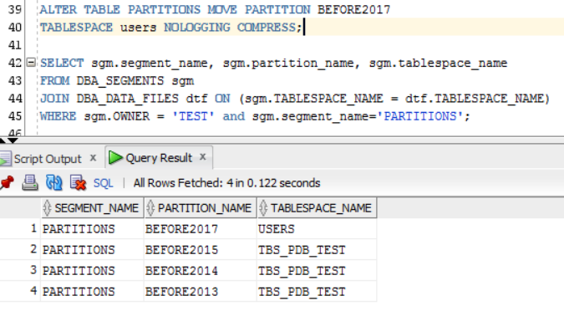

1. Split partitions. Moreover, both this partitions will be in our new tablespace users.

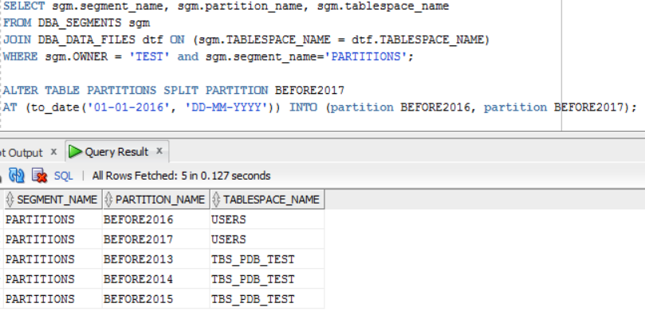

1. Truncate partitions. It is still in the hierarchy, but it is empty.

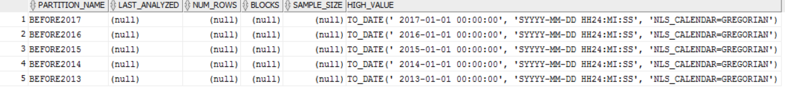

1. Coalesce partition. Coalescing partitions is a way of reducing the number of partitions in a hash-partitioned table or index, or the number of subpartitions in a *-hash partitioned table. When a hash partition is coalesced, its contents are redistributed into one or more remaining partitions determined by the hash function. The specific partition that is coalesced is selected by the database, and is dropped after its contents have been redistributed.

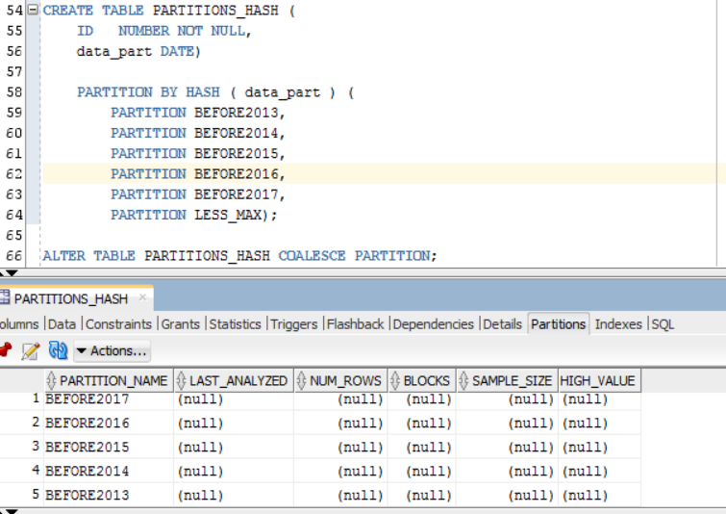

# Analytical task

## Partitioning

My Fact table will be partitioning by sale day. I have some information from 5 March 2016 till 7 April 2016. It can help to analyze how many sales we have per each day. Also we can analyze different types of cars sold per each day or which shop sold more every day

## Business

I want to analyze .which brand of car sales more per each day. In other words what is the bestseller for the day. When we tick on the point we found out which brand sold more.

